AZURE CONTAINER APPS:-
Azure Container Apps (ACA) = Fully managed serverless container platform in Azure
👉 Tum bina Kubernetes manage kiye containers run kar sakte ho.
Azure Container Apps = AKS का छोटा भाई। Kubernetes का पावर बिना Kubernetes की दिक्कत।Serverless containers बोले तो - code का container बनाओ, deploy कर दो। Scale-to-zero, KEDA, Dapr सब built-in। Node pool, YAML, kubectl का झंझट नहीं।

🔹 Kya hai?
- Azure service jo containers (Docker images) ko run karti hai
- Backend me Kubernetes hota hai but tumhe manage nahi karna padta
- Microservices & APIs ke liye best

🔹 Key Features
- Serverless
  - Auto scale (0 se bhi start ho sakta hai → cost save)
- KEDA-based scaling
  - HTTP, queue (Service Bus, Kafka) se scale
  - HTTP request नहीं आई तो 0 replica। Queue में message आया तो 1 से 100 scale।
  - Kafka, RabbitMQ, Service Bus, Azure Queue, CPU, Memory - किसी से भी scale हो जाएगा।
- Revision management
  - Multiple versions run kar sakte ho (blue-green deploy)
- Built-in ingress
  - Public/private access easy
- Dapr support
  - Microservice communication simplify
  - Pub-Sub, State Store, Service Invoke, Secrets - code में library नहीं डालनी। Sidecar खुद दे देगा।
  - dapr publish --pubsub redis --topic orders बस इतना लिखो।
Environment = Mini K8s
सारे Container Apps एक "Environment" में रहते हैं। एक VNet, एक Log Analytics, आपस में mTLS auto। Service Mesh हल्का वाला free में।

🔹 Use Case
- Microservices architecture
- Event-driven apps (queue based)
- APIs / backend services
- Background jobs

🔹 ACA vs AKS
Feature | ACA | AKS
Management | Fully managed | Tum manage karte ho
Complexity | Simple | Complex
Control | Limited | Full control
Use | Fast deployment | Enterprise control

🔹 Simple Flow
- Code → Docker image
- Image → Azure Container Registry
- Deploy → Container App
- Auto scale → traffic ke hisab se

🔹 Real Example
Frontend → ACA
Backend API → ACA
Queue (Service Bus) → trigger scaling
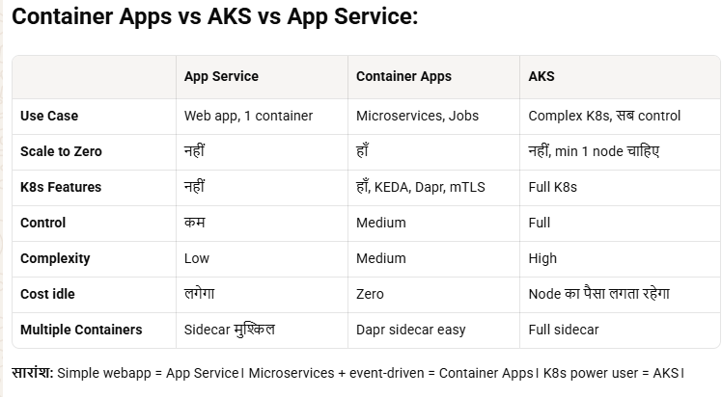
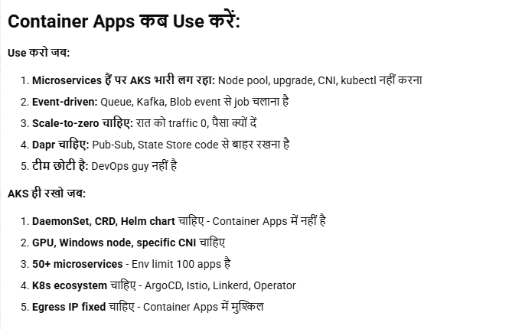

- ADO PIPELINE WORK FLOW :-
ADO Pipeline Flow (React → Azure Container Apps)
1. Build Stage
Node setup
npm install
npm run build
2. Security Scan
Mend scan
Aqua/Trivy scan (image banne ke baad bhi chalega)
3. Docker Build & Push (same as AKS)
Docker build image
Tag (latest / buildId)
Push to ACR
4. Deploy to Container Apps (Main Change 🚀)
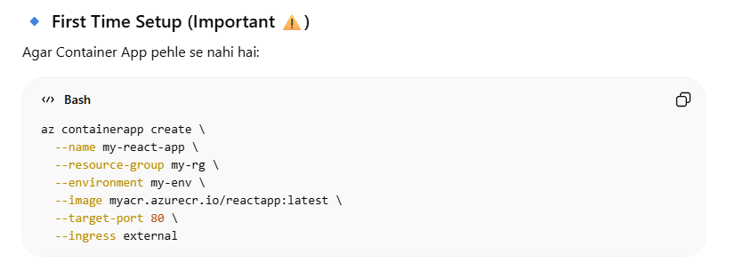
👉 Yaha AKS ki jagah use hoga: inlince script se deploy :-
az containerapp update –name lol –resourcegroup lol1 –imagename acr wla
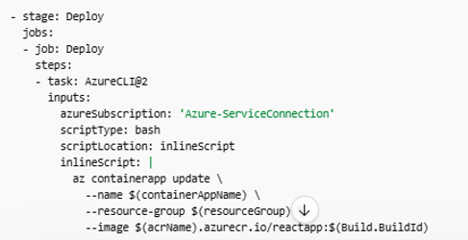
Azure CLI (az containerapp)
🔹 ADO YAML (Simplified)
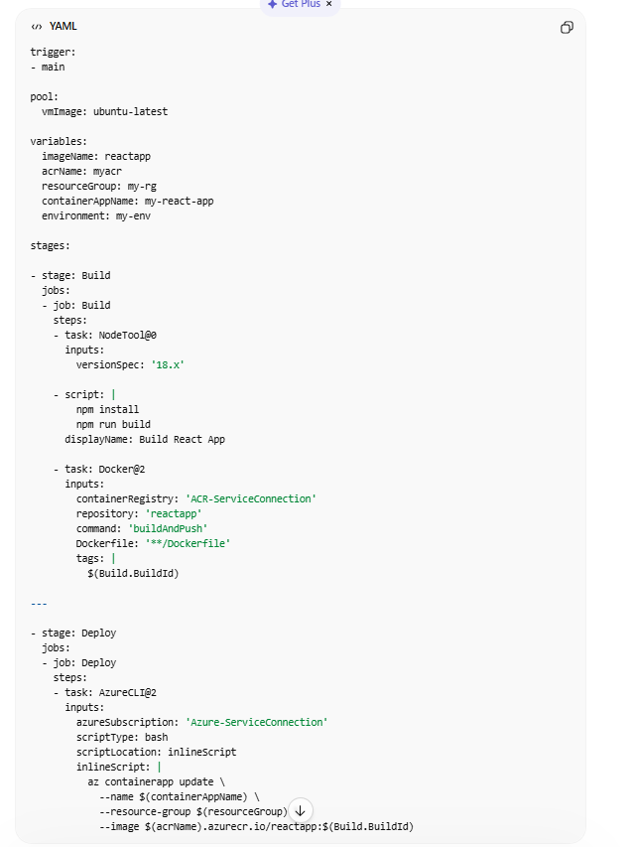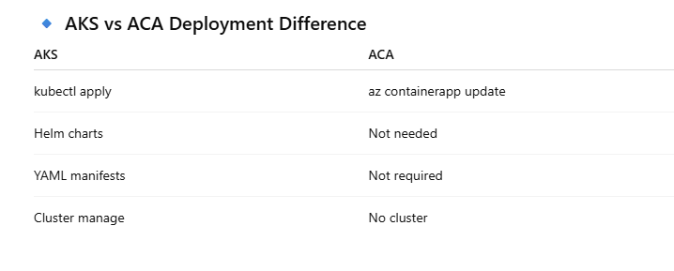
🔹 Key Points (Interview 💡)
ACA = serverless containers → no cluster mgmt
CI same (build + push image)
CD change = az containerapp update
Revision-based deployment (auto versioning)
UPDATE/UPGRADE:-
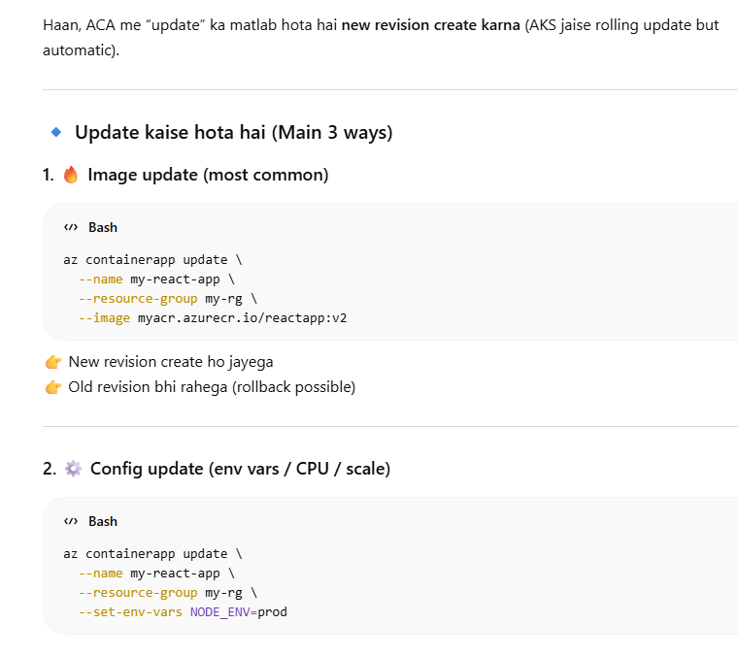
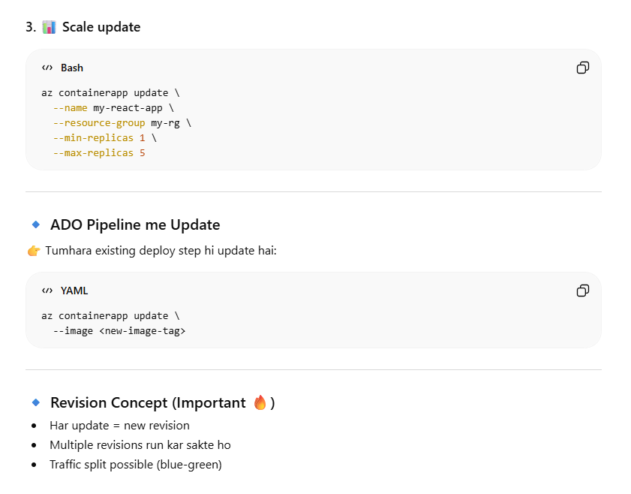
Key Difference (AKS vs ACA Update)
- AKS → rolling update via deployment YAML
- ACA → auto revision + traffic control

🔹 Short Interview Line
👉 “ACA me update = new image push + containerapp update → new revision create → traffic shift / rollback supported”

CONFIG/SECRET :-
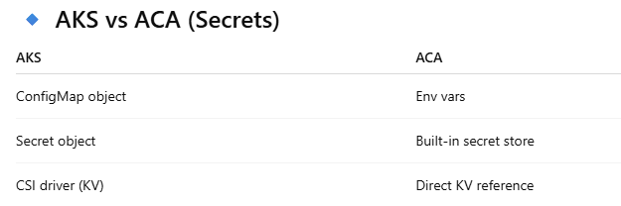
Haan, Azure Container Apps (ACA) me ConfigMap + Secret dono ka concept hota hai—but AKS jaisa exact object nahi, yaha env vars + secrets + Key Vault refs se handle hota hai.

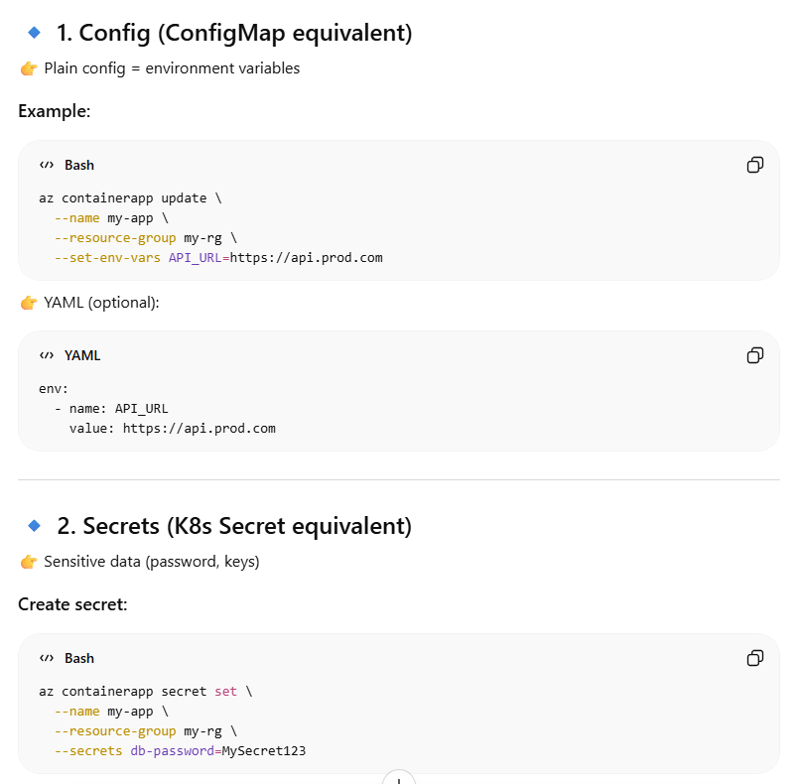
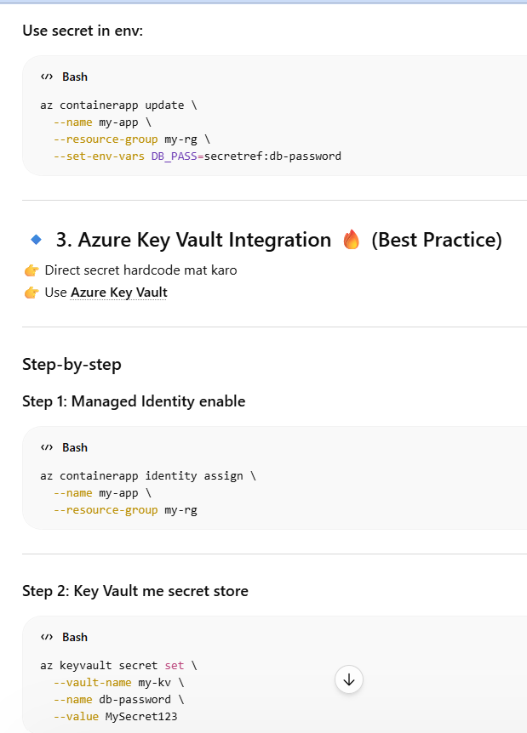
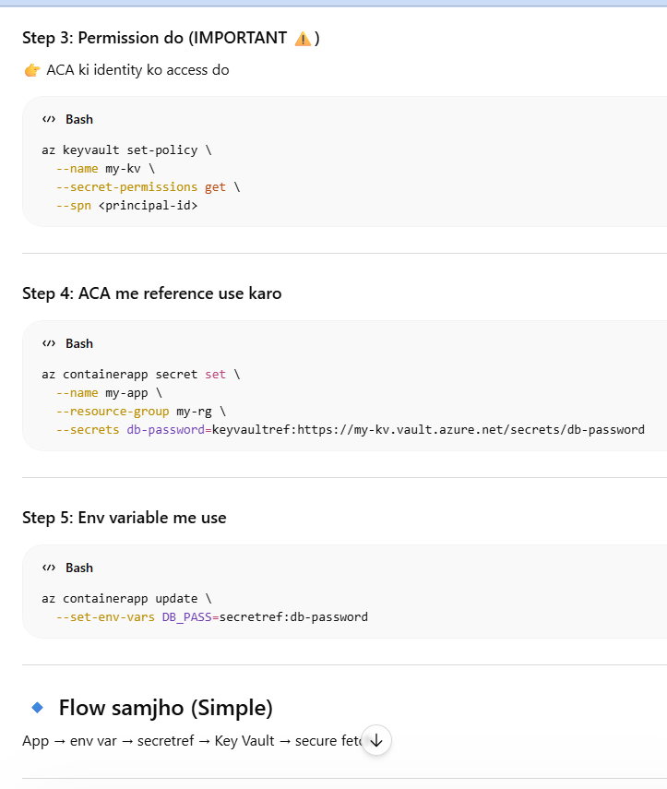
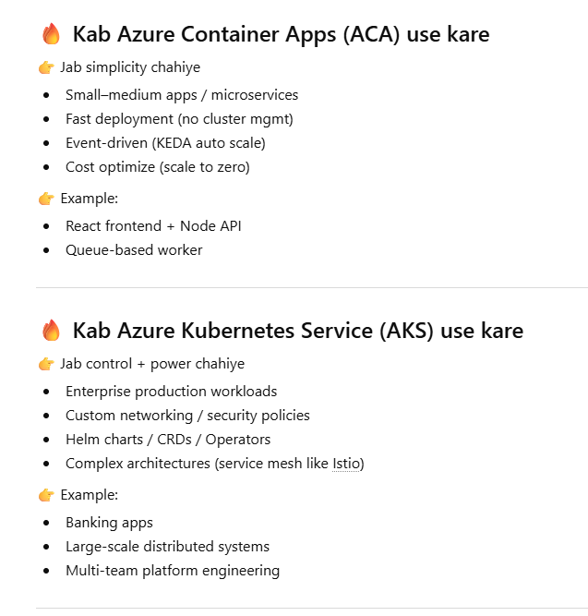
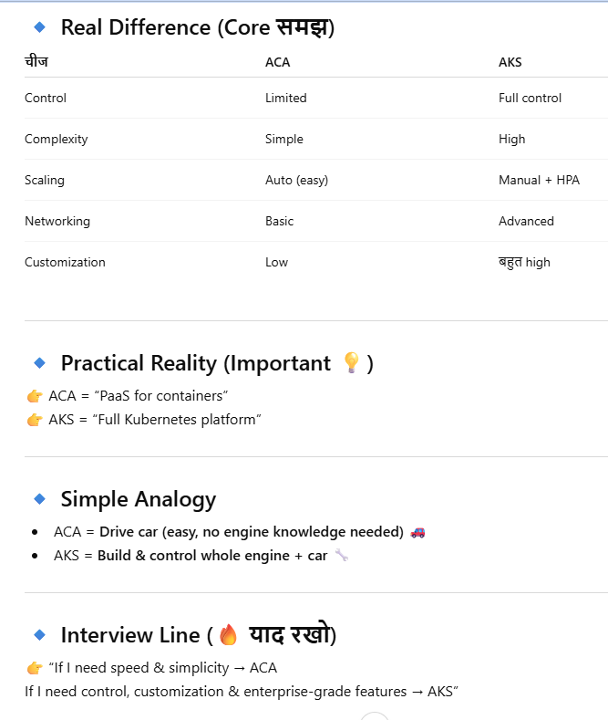
Final Truth
👉 Tum AKS se sab kuch kar sakte ho (even ACA jaisa)
👉 But ACA se AKS wali flexibility nahi milegi
-----------------------------
AZURE APPS HAI TO AZURE CONTAINER APPS KA NEED ?
